

ATROKSIA

EVERYTHİNG ABOUT



20 Haziran 2023-

MAP OF ATROKSIA

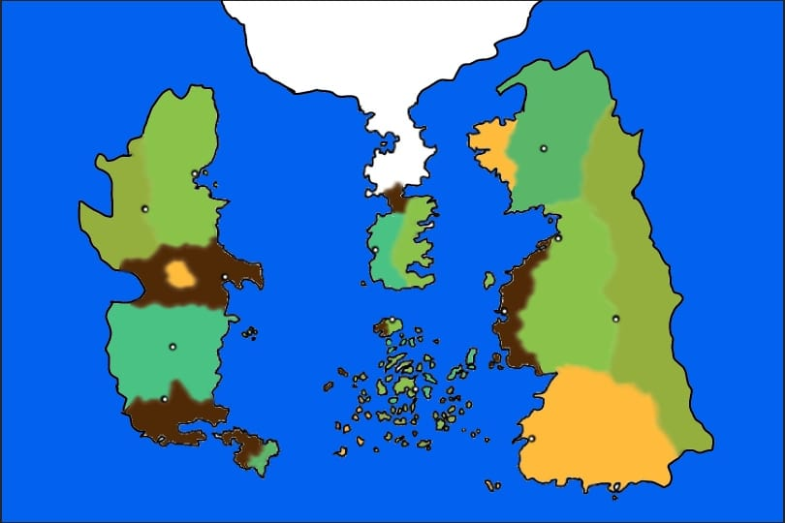

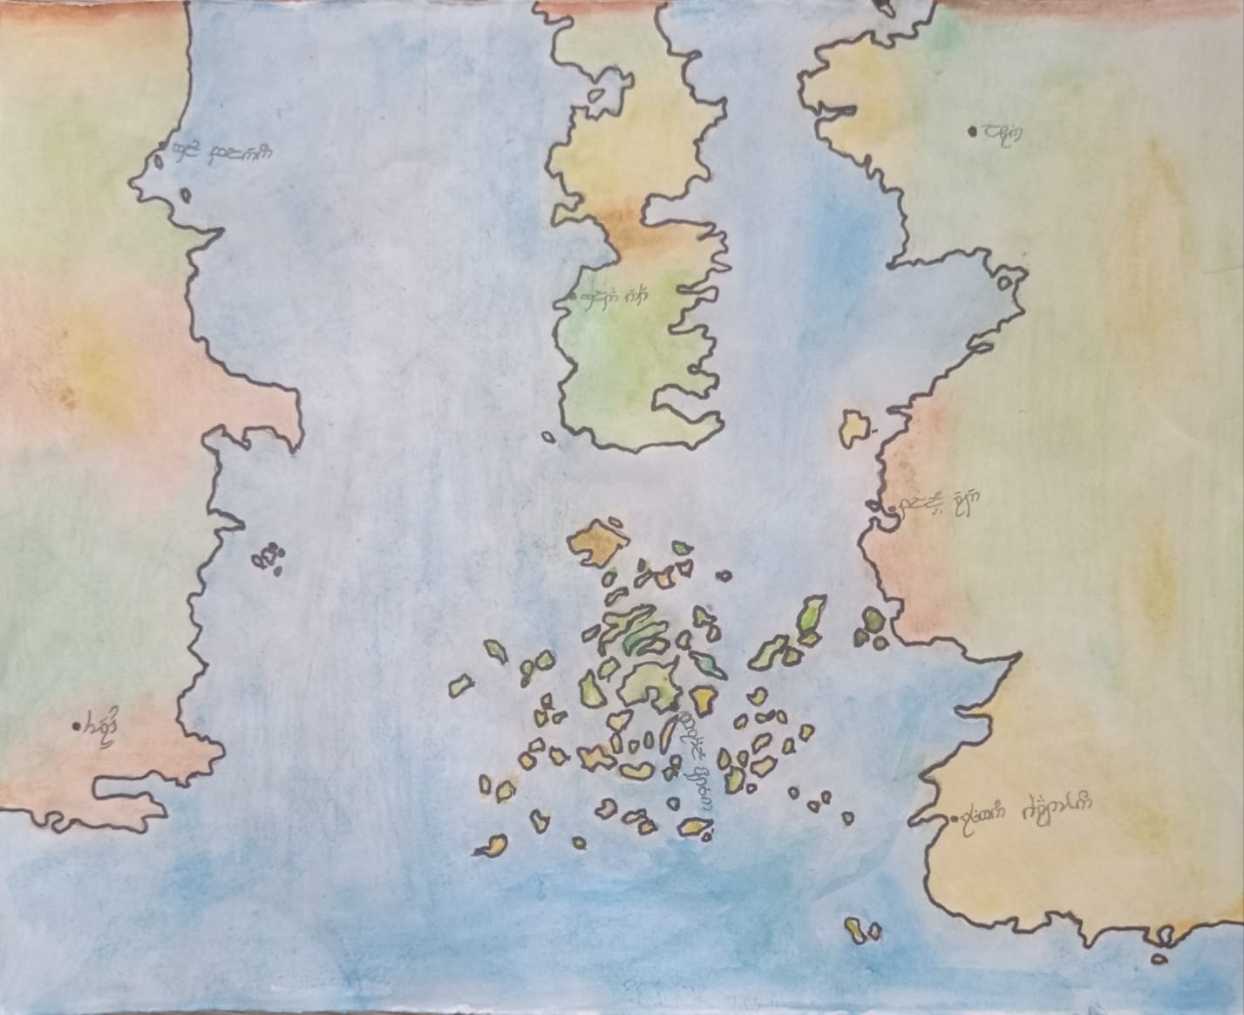

CONTINENTS (west to east) :

# Vandar

# Trachý

# Mugel

# Wetan

MYTHOLOGY :

çizgi film, memeli, çizim, sanat içeren bir resim

Açıklama otomatik olarak oluşturuldu Main Goddess of the Atroksian panthenon Anthepis

Fernandas: God of air and wind

Retia: Godess of the nature

Nymeeron: God of sea

Hephule: God of mountains and rocks

Hermanus: God of death

## At first, there was just Anthepis. She decided to create a race to help her called aasimars while she was carrying out her missions. Together they created the Atroksia the world of living and Hamnisia the world of the death. She allowed them to build a fortress-like city that was also the only temple of Athepis in the Atroksia, which was later called Mecridio on Genoh Island.

AGES

# Age of Trees (1-504):

## Natureldar woke up in Mugel. The elves united with the ents and fairies and founded the Tolyarin Constitutional Kingdom. The dryads founded nomadic tribes. Aasimars traveled to Mugel to inform the new folks about the creation and the world.

# Age of sprıng (505-1376):

## The elves were divided into two groups: high elves and wood elves, and they left Tolyarin. The high elves migrated to Wetan and founded Asphara, while the wood elves and dryads migrated to Vandar and founded Artalion. However, the dryads preferred not to preserve their nomadic culture; instead, they built a city in the trees out of wood. The ents and fairies who remained in Mugel founded Funtunia. The third king of Asphara, Elion, married the descendant of the head aasimar. Their second son founded the Council of the Sun in the south of Genoh island. The purpose of the Council was to unite all of the priests, sorcerers and alchemists. All races lived in peace.

# Age of rocks (1377-2203):

## Druedain and Aledain awoke in the southern Vandar. While the dwarves stayed and founded the Kadaht, men and halflings went north and founded Dwalingrad. Satyrs went further north than the Dwalingradians and founded Tranagorm. Later, the Artalionian king appointed a group of explorers to invite the Secondborn to Artalion. The elven explorers invited the Dwalingradians and some of the satyrs to Artalion, promising the uninhabited lands of Wetan. They accepted the offer and headed north, later migrating to Wetan with trade ships between Artalion and Asphara. When they left Dwalingrad, the Kadaht dwarves burned the rain forests of Dwalingrad. The strict rules of the high elves did not sit well with the Newborns, whom they considered inferior to themselves, so they arrested them and exiled them to the south of Wetan. Halflings and men of the mountains who settled in the mountains of central Wetan founded Athaiand. Men of Tusken, who settled in the deserts of southern Wetan, founded Kiriñe. The men of the Isles discovered new places with the satyrs who came to Wetan. They called this continent Trachy, which means "islands" in their own language, and later settled on this new continent, founding Dagorazulv. The Council of Crows was established in the Haven of Endunae by the kıng Barcıus of Athaıand. The council included a delegate from each country or organization in the Athaiand and their purpose was to make decisions about international issues and maintain peace among the world.

# Age of Savagery(2204-:

## The Artalionian elves banished the dryads because they wanted to gain the sympathy of the Aspharans. The dryads migrated to Tranagorm. The government of Tranagorm welcomed the dryads, who were mostly female, as the males were mostly killed in tribal wars, and most of the female satyrs were resettled in Trachy. So, they formed an alliance to prevent the extinction of both species. But by the miracle of Anthepis, both races were able to remain separate, even if they bred together (female: dryad, male: satyr).

## The Kingdom of Asphara and Political Tensions:

## The Council of Crows operates from the Haven of Endunae in Mesowetan, acting as peacekeepers in the situations of rising tensions. Although their goal is mediation, their proximity to Asphara puts them in constant conflict with the high elves. Asphara, a kingdom of high elves, was once a dominant power in the continent of Wetan. King Elion II, who comes from a celestial bloodline forced the Artalionian king Thaliondir to exile the dryads to Tranagorm. A group of elven rebelions against the Aspharan syphatizers started a coup in Gul Blenon. They beheaded the King Thaliondir. Eryndor the leader of the coup became the new king of Artalion. Queen Elira pushes for an alliance with Artalion to restore unity, but traditionalists like Lord Thalion fear it will weaken Asphara’s power. Under King Eryndor, Artalion, grows defiant against Asphara's dominance. The formation of the Alliance of the Greenroot, including the dryads and satyrs, pushes for the reclamation of Ferdonan and a return to nature-focused ways, setting the stage for potential war. The sacred city of Funtunia, home to the ents and fairies, becomes a casualty in the brewing conflict. Queen Lunara’s attempts at peace are thwarted by Lord Thalion’s destruction of the city and the assassination of Ambassador Alaric of Artalion in Lorien, Asphara’s capital, marks the failure of diplomacy and forces the Council to adopt more direct actions in the war. escalating tensions between the elven factions. The dryads, led by Matriarch Sylra, formed an allience with the corsairs of Trachy. Later the corsairs launched attacks on Aspharan trade routes.

## The War of Roots and Stones (Dagor Tindon se Alqua):

## The war breaks out between Asphara and Artalion, with the dryads and satyrs fueling the rebellion. The dwarves form a secret alliance with Asphara. During the war all of the armies of Artalion, Tranagorm and the Corsairs of Trachy were in Mugel, fighting with Asphara. But during the war the corsairs left the battlefield. That is why the Greenroot was mostly damaged even though they had won the war. Later the Kadathian forces attacked Oblask and Gul Blenon, they were able to destruct and corrupt the cities with no effort. After the war in the mugel when the greenrott finnally arrived at gul blenon they saw the other half of the Asphran army, Kadathian forces and the destructed city of Gul Blenon. Later the Greenroot armies were destroyed.

RACES

# Aasimar

# 

# NATURELDAR:

# Elves

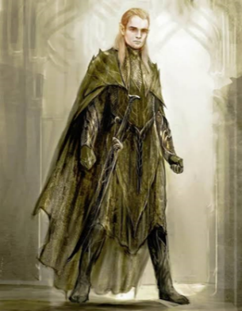 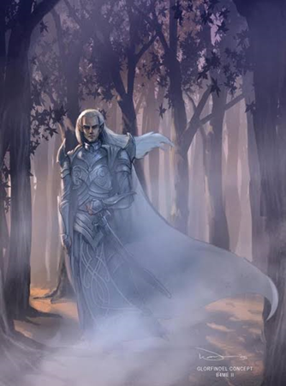

## Wood elves Hıgh elves

# Ents

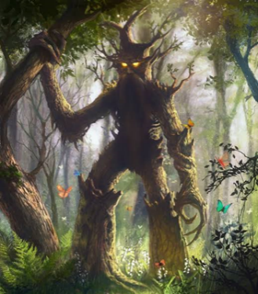

# Dryads

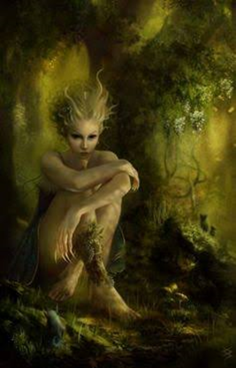

# Faırıes

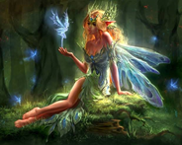

# AULEDAIN:

# Satyrs

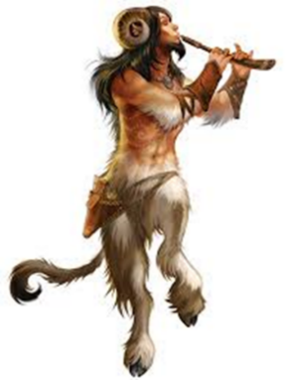

# Dwarves

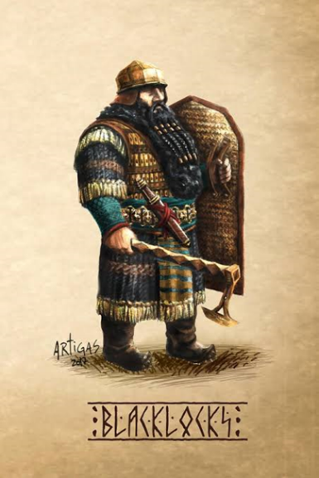

# DRUEDAIN:

# Men

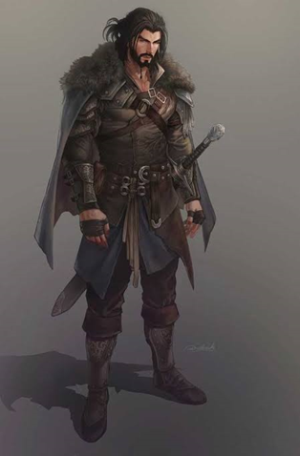 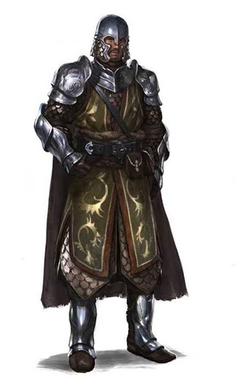 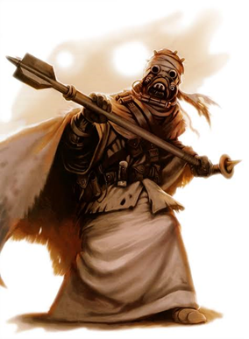

# Halflings

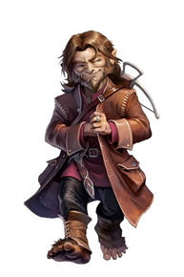

KINGDOMS (w-e) & INFO

Kıngdoms of Age of trees

# TOLYARIN(75-504) :

## Capıtal: Glad EneTH

## Contınent: Mugel

## Races: elves , ents , faırıes

# DRYAD TRIBES(30-503) :

## Contınent: Mugel

## Races: Dryads

Kıngdoms of Age of Sprıng

# FERDONAN(506-2202) :

## Capıtal: Robar

## Continent: Vandar

## Races: Dryads

# ARTALION(306-) :

## Capıtal: Gul Blenon

## Contınent: Vandar

## Races: wood elves

# FUNTUNIA(304-2216) :

## Capıtal: Glad EneTH

## Contınent: Mugel

## Races: ents , faırıes

# ASPHARA(310-3604) :

## Capıtal: lorıen

## Contınent: Wetan

## Races: hıgh elves

Kıngdoms of Age of Stones and Heroes

# KADAHTH(1396-3604) :

## Capıtal: THeru

## Contınent: Vandar

## Races: dwarves

# FERDONAN(306-2202) :

### CAPITAL: ROBAR

### CONTİNENT: VANDAR

### RACES: DRYADS

# DWALINGRAD(1398-2029):

## Contınent: Vandar

## Races: men , satyrs , halflıngs

# ARTALION(306-2204) :

## Capıtal: Gul Blenon

## Contınent: Vandar

## Races: wood elves

## TRANAGORM(1405-) :

## Capıtal: Oblask

## Contınent: Vandar

## Races: satyrs , , dryads

# FUNTUNIA(304-2216) :

## Capıtal: Glad EneTH

## Contınent: Mugel

## Races: ents , faırıes

A

# DAGORAZUVL(2056-3604) :

## Capıtal: BrıTHıl Oktıon

## Contınent:Trachý

## Races: men of ısles , satyrs

hg

HH

# ATHAIAND(2033-3604) :

## Capıtal: Plual Ered

## Contınent: Wetan

## Races: men of mountaın , halflings

# KIRIÑE(2001-3604):

## Capıtal: Rısmun Cardhon

## Contınent: wetan

## Races:men of tusken

# ASPHARA(310-2545) :

## Capıtal: lorıen

## Contınent: Wetan

## Races: hıgh elves